Adding an email signature

- Signature templates from Marketing team
- How to add signature

- Signature templates from Marketing team
The Marketing Team has prepared 2 templates for signatures; one containing the business phone number and one without it. You will need to copy these templates into your signatures and edit them there to include the correct data. Both templates can be found in Word files, ready to be copied below:

- How to add signature

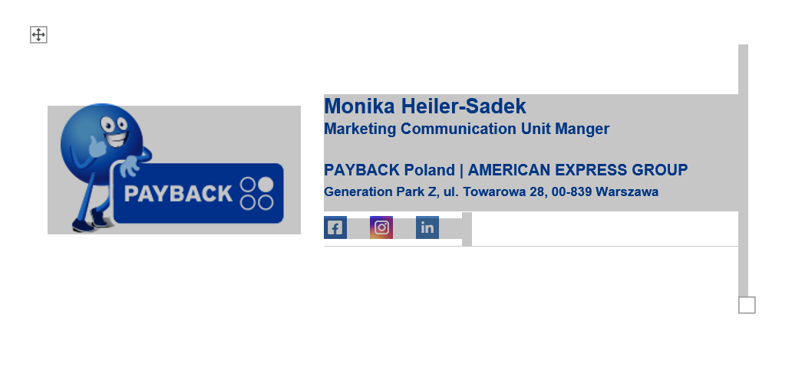 | - Open the template file of your choice from those provided above.  - Select the entire document (ctrl + A) and copy it (ctrl + C).
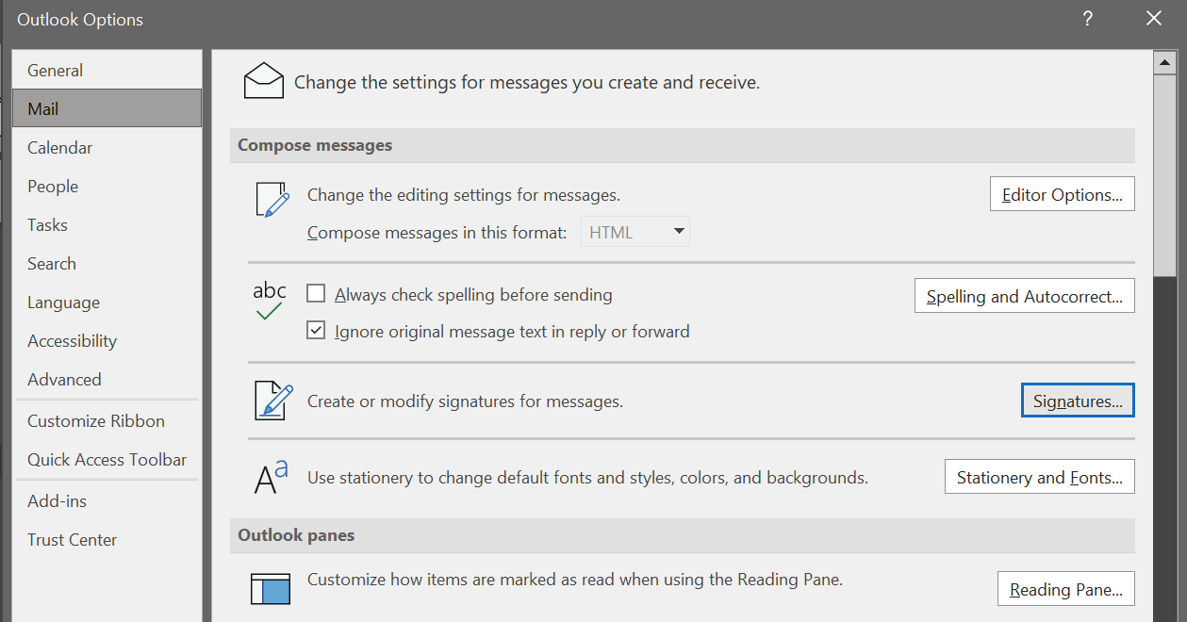 | - Start Outlook, choose File -> Options -> Mail -> Signatures.
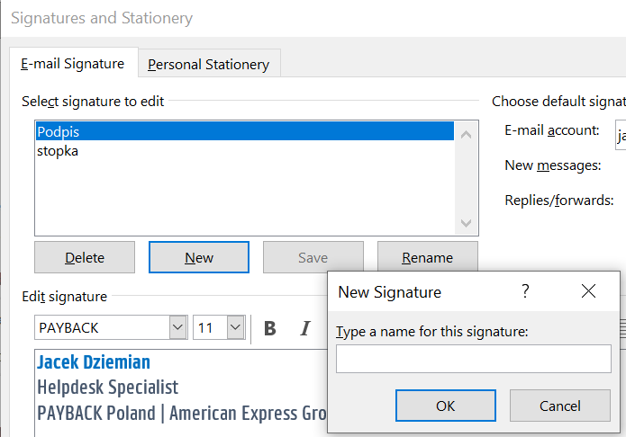 | - Select New and give a name to your signature.
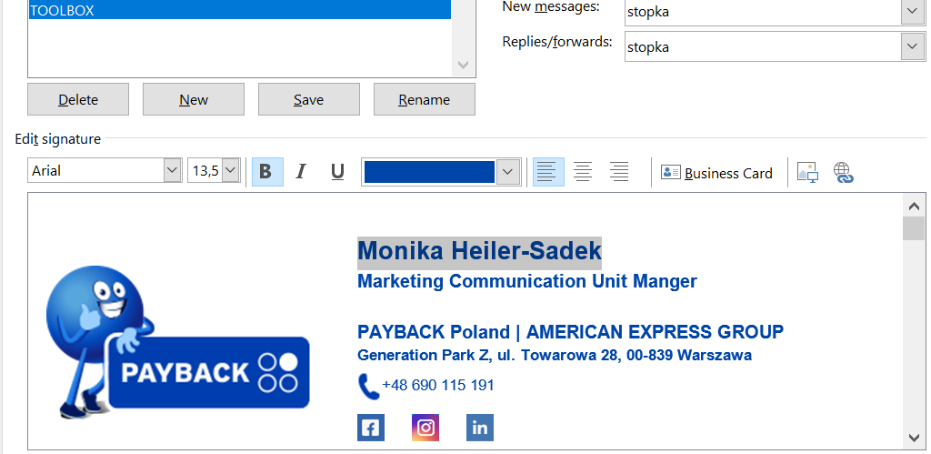 | - Paste (ctrl + V) the template you copied earlier and edit it by inserting your data (name, position and phone number).
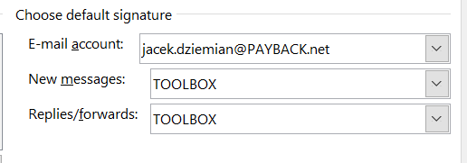 | - Choose whether you want the footer to appear only in new emails or also in replies and forwarding and select the appropriate options, then press OK.

