USB-Encryption
Windows Clients v.1.0

Content

USB-Stick / -Drive Encryption ........................................................................................................ 2
Start USB Encryption ........................................................................................................................... 2
Start Bitlocker Encryptionassistent ................................................................................................. 2
Create password .............................................................................................................................. 4
Save recovery key on U: Drive ......................................................................................................... 4
Stop USB Encryption ............................................................................................................................ 7
Resume USB Encryption ...................................................................................................................... 8

Change password of USB-stick ...................................................................................................... 9
Current password is known ................................................................................................................. 9
Password is not known but recovery key exists ................................................................................ 11

Decrypt USB-stick / disable Bitlocker .......................................................................................... 15

FAQ ........................................................................................................................................... 17
Can I use my BitLocker encrypted USB-sticks with non proprietary devices? .................................. 17
Do with BitLocker encrypted USB-sticks only work with Microsoft systems? .................................. 17
Will the data on the USB-stick get lost through encryption? ............................................................ 17
Do I have to encrypt my USB-stick? .................................................................................................. 17
Can I continue working during encryption? ...................................................................................... 17

In order to guarantee the security of corporate data, all external storage media has to be encrypted. The following procedure describes how to encrypt a USB stick.

The encryption takes a very long time, the USB stick must not be disconnected during encryption.

USB-Stick / -Drive Encryption

Start USB Encryption

Start Bitlocker Encryption Assistant

Connect USB-stick with device; a pop-up appears:

„Encrypt this drive using BitLocker Drive Encryption“
Choose this option if you want to encrypt your USB-stick. Furthermore you have to open a ticket at helpdesk and apply for USB opening. After both steps you are able to save data on the USB-stick.

„Don’t encrypt this drive“
Data cannot be copied to the USB-stick .

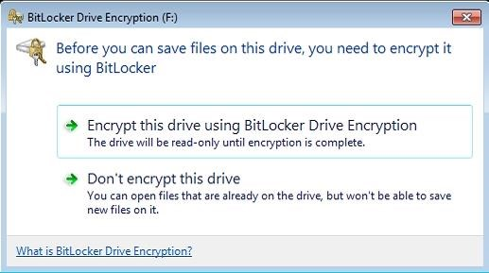
"Encrypt this drive with BitLocker
Drive Encryption " will start
BitLocker encryption

or

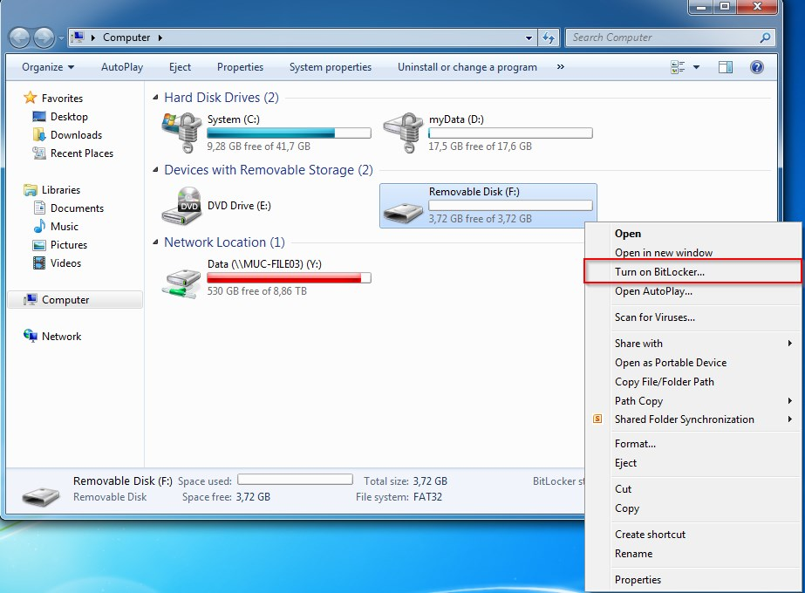
If the pop-up doesn´t appear, BitLocker encryption can be started alternatively:

Computer -> right-click on USB-stick
-> Turn on BitLocker…

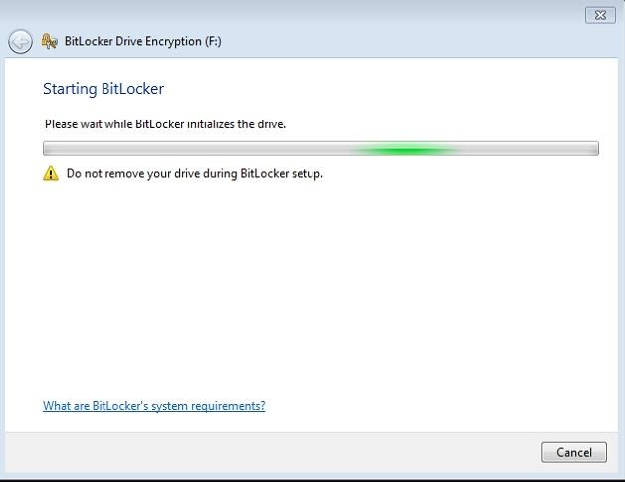

Starting BitLocker Encryption…

Create password

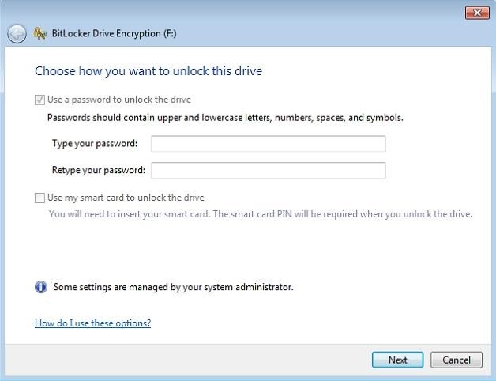

Password has to be created. It will be needed to unlock USB-stick on all devices.

Use of a smart card is not possible.

Save recovery key on U: Drive

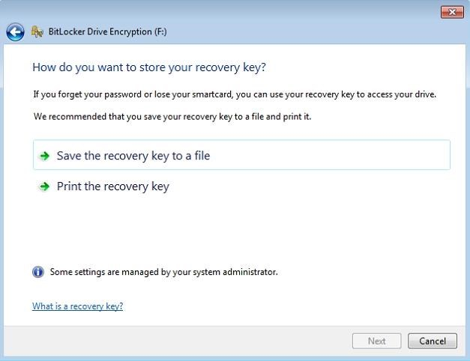

Recovery key is needed to unlock USB-stick without the password.

To save the key choose „Save the recovery key to a file“

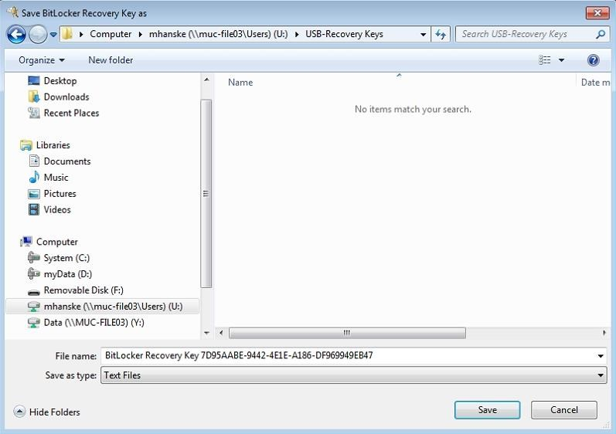

The key should be saved on U:
Drive so it can´t get lost.

In this example a folder „USBRecovery Keys“ has been created and the key saved.

Attention: If the password AND the recovery key get lost the USB-stick can’t be unlocked anymore!

Office IT is not saving USB-recovery keys.

In this case USB-stick has to be formatted. All data saved on the USB-stick are lost.

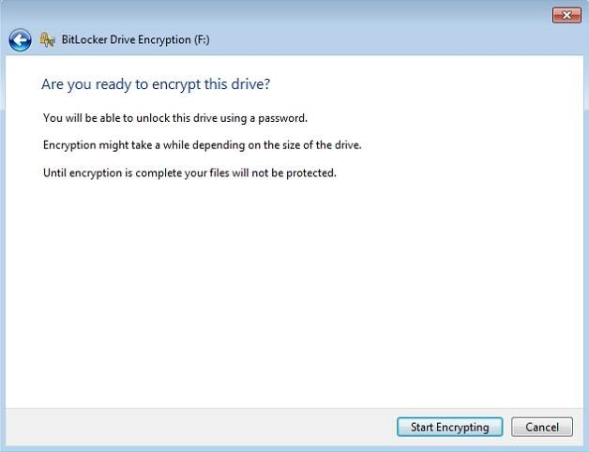

Encryption should only be started after saving of recovery key.

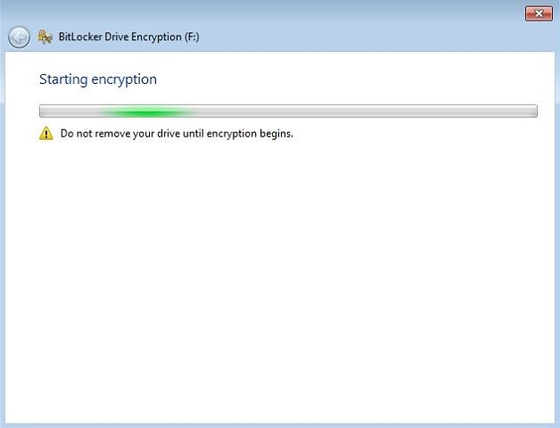

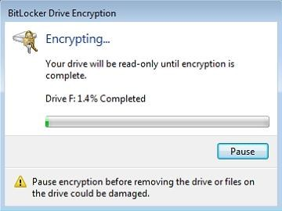

Encrypting takes a long time. If USBstick has to be disconnected before the end of encryption, please read
“Stop/resume Encryption”

Duration:
1 GB : approx. 20 min

Stop USB Encryption
To disconnect the USB-stick before end of encryption the encryption has to be stopped.

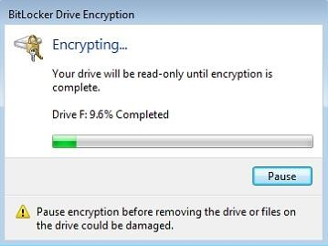

Click “Pause” in Window “BitLocker Drive Encryption”.

It takes a while until the encryption has stopped

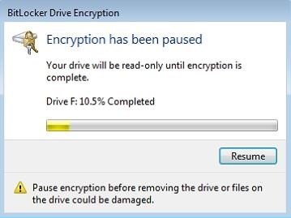

If the window shows „Encryption has been paused“ and the progress bar is yellow encryption has been paused.

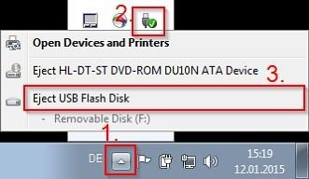

Now you can unplug your USB-stick as described in the picture

Resume USB Encryption
Encryption can be resumed at every company machine (with at least Windows 7). USB Password is needed. If USB-stick is connected to device a password request appears:

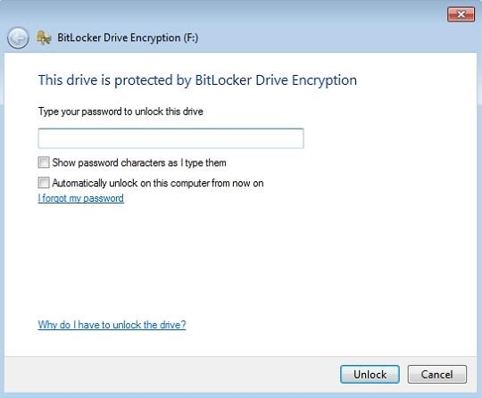
Password has to be entered and encryption will resume automatically

Change password of USB-stick

Current password is known

Password has to be entered to unlock USB-stick

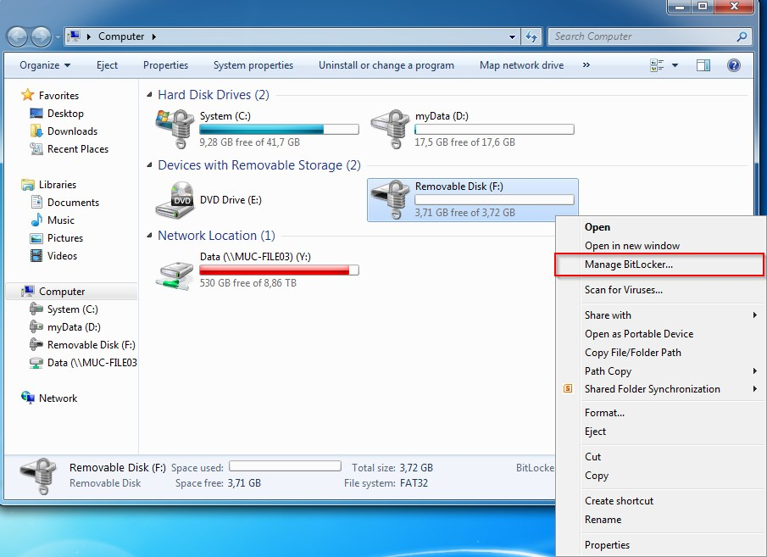
Computer -> Right-click on USB-
Stick -> Manage BitLocker

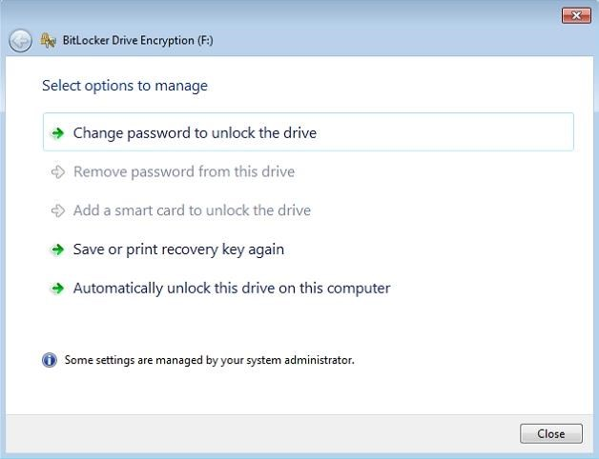
Now password can be changed with option „Change password to unlock the drive“

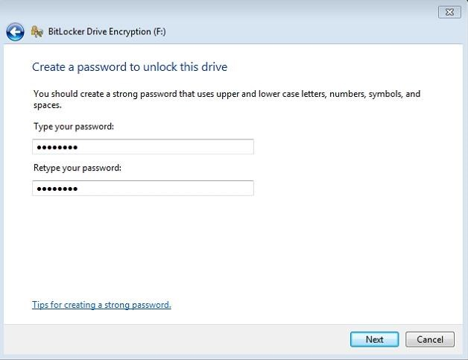

Password has to be entered twice

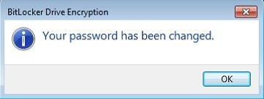

Password is not known but recovery key exists

Connect USB-stick to device.

Click „I forgot my password“

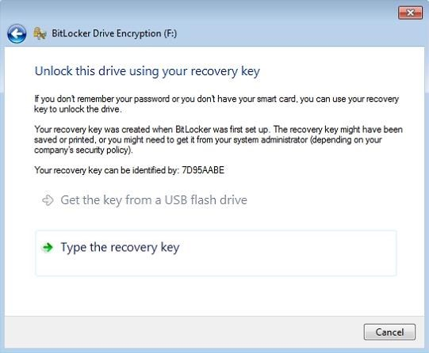

Click „Type the recovery key“

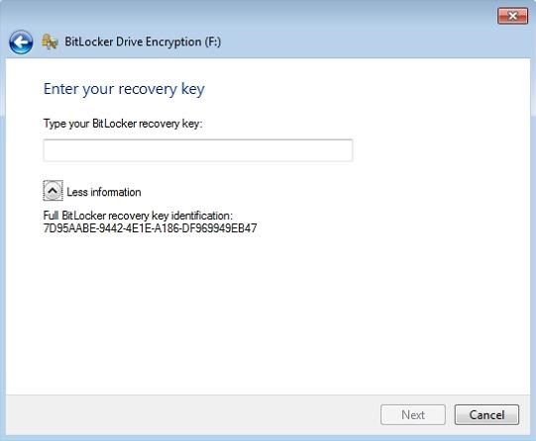
Click „More information”
The recovery key identification will appear.

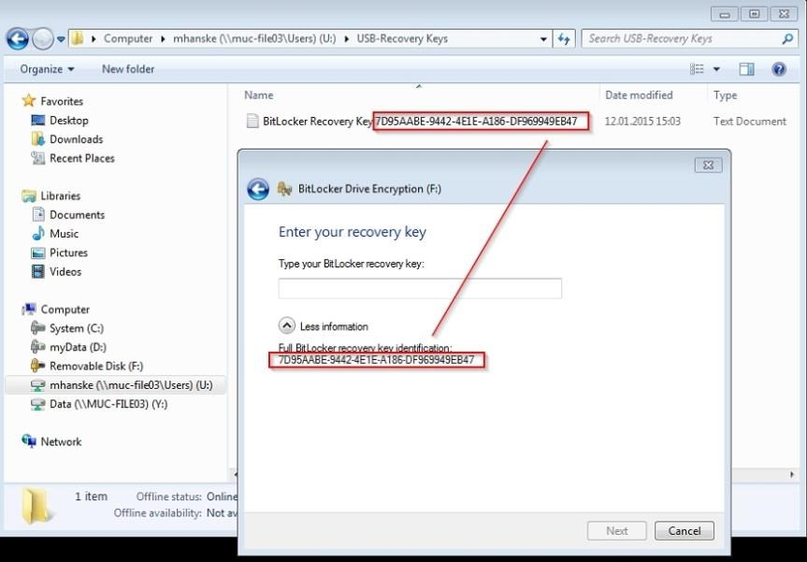

Recovery key with equal identification number has to be opened.

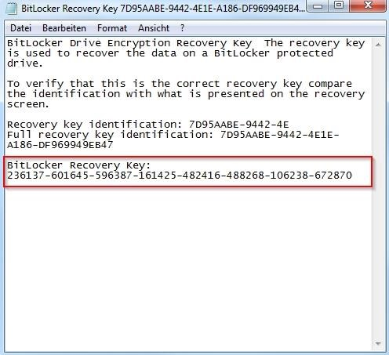

Copy Bitlocker-Recovery Key
In this case
„236137-601645-596387-161425-482416-
488268-106238-672870“

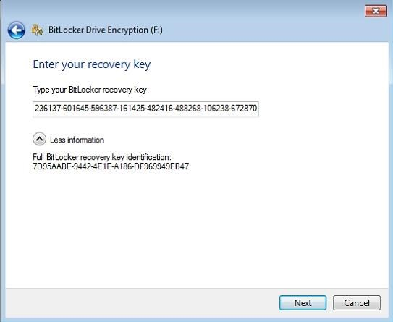
Paste

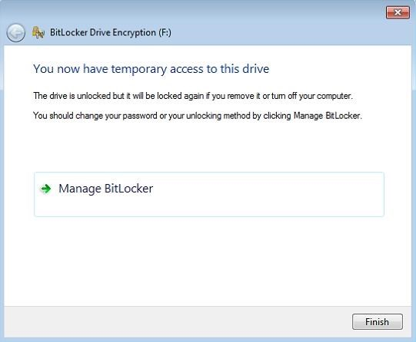

Click on „Manage BitLocker“

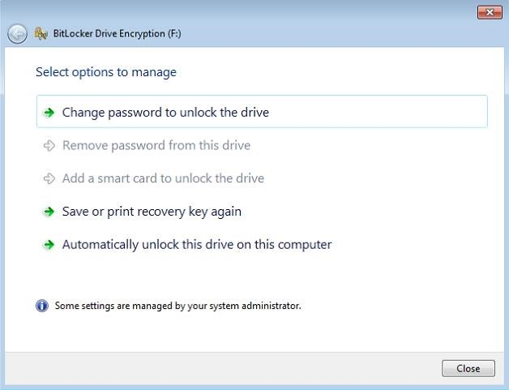
Password can be changed with option „Change password to unlock the drive“

Password has to be entered twice

Decrypt USB-stick / disable BitLocker

To disable BitLocker the USB-stick has to be formatted. All on the stick stored data will be deleted. Make sure the data has been saved at another location.

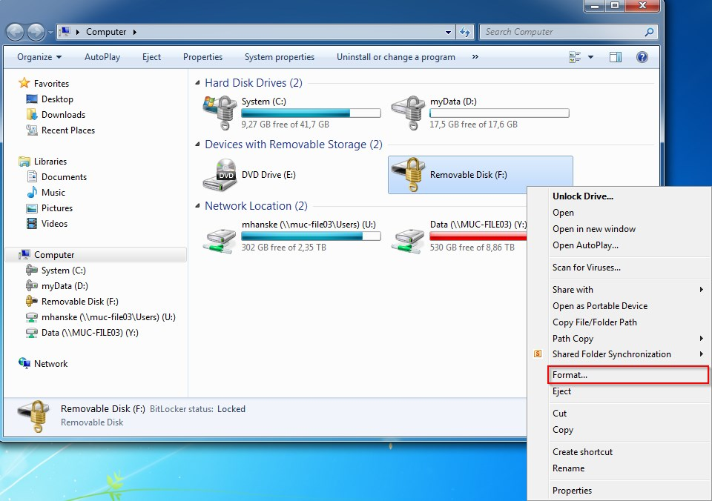
Right-click on USB-stick -> Format

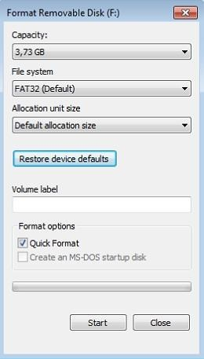

Click „Restore device defaults“ -> „Start“


-> “OK”



FAQ

Can I use my BitLocker encrypted USB-stick with non-proprietary devices?

Yes, the USB-stick can be used with non-proprietary devices but a Microsoft operating system is mandatory (e.g. Windows XP, Windows Vista, Windows 7, Windows 8). Also the password of the USB-stick has to be known.

Do with BitLocker encrypted USB-sticks only work with Microsoft systems?

Yes, a Microsoft operating system is mandatory (e.g. Windows XP, Windows Vista, Windows 7, Windows 8).

Will the data on the USB-stick get lost through encryption?

No. But the USB-stick must not be disconnected during encrypting process.

Do I have to encrypt my USB-stick?

The encryption is mandatory if data has to be copied from a proprietary device to the stick. To copy data from USB-stick to a company device encryption is not needed.

Can I continue working during encryption?

Yes.

