HOW-TO: Open a Membership Request v.1.0

To open a request just follow the steps as shown below:

- Open the User Access Management Tool (can be found in your favorites):

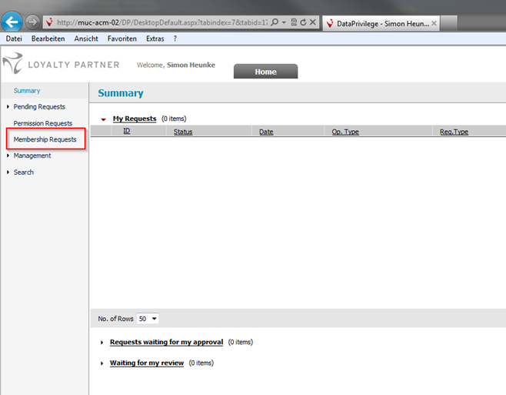

- Fill the form like you are used to for folder permissions:

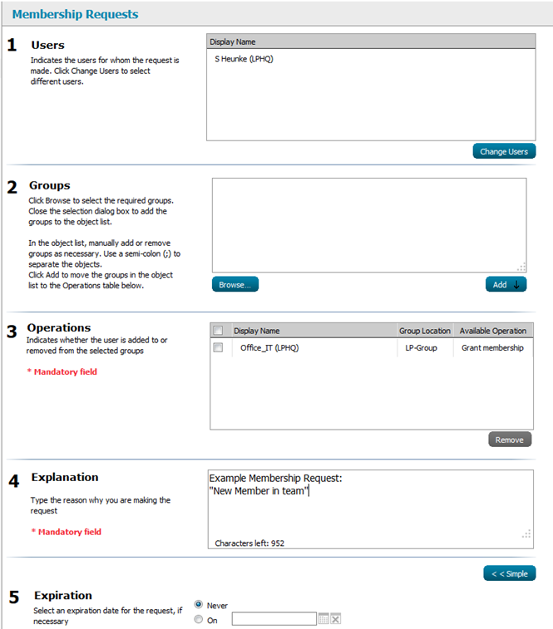

After this the group owner will be informed about your request and can handle this. After that step you will get an information mail about the decision and if the request has been approved you will be added to the distribution list automatically.

If you have any questions or problems with that new feature please contact helpdesk.

Thanks and Regards
Your Office-IT

