How-To: Create a permission request with our new Permission Management Tool Version 1.0

- Open your Browser (Internet Explorer)
- Go to: http://muc-acm-01/dp
At a later point that link will be added to your favorites named
“Permission-Management”.
- The start page of our new Permission Management Tool will appear:

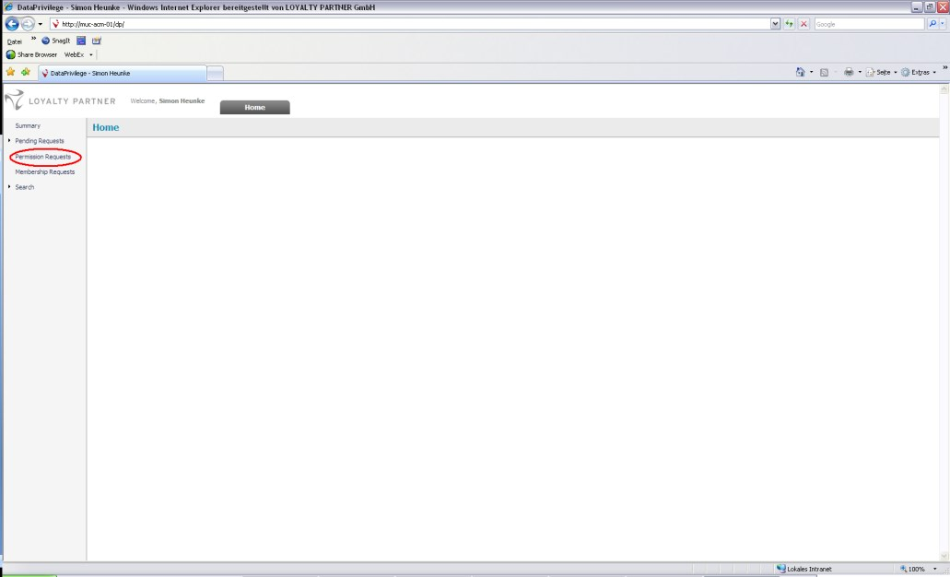

- Click onto “Permission Request” to create a new request. The following site will be opened:

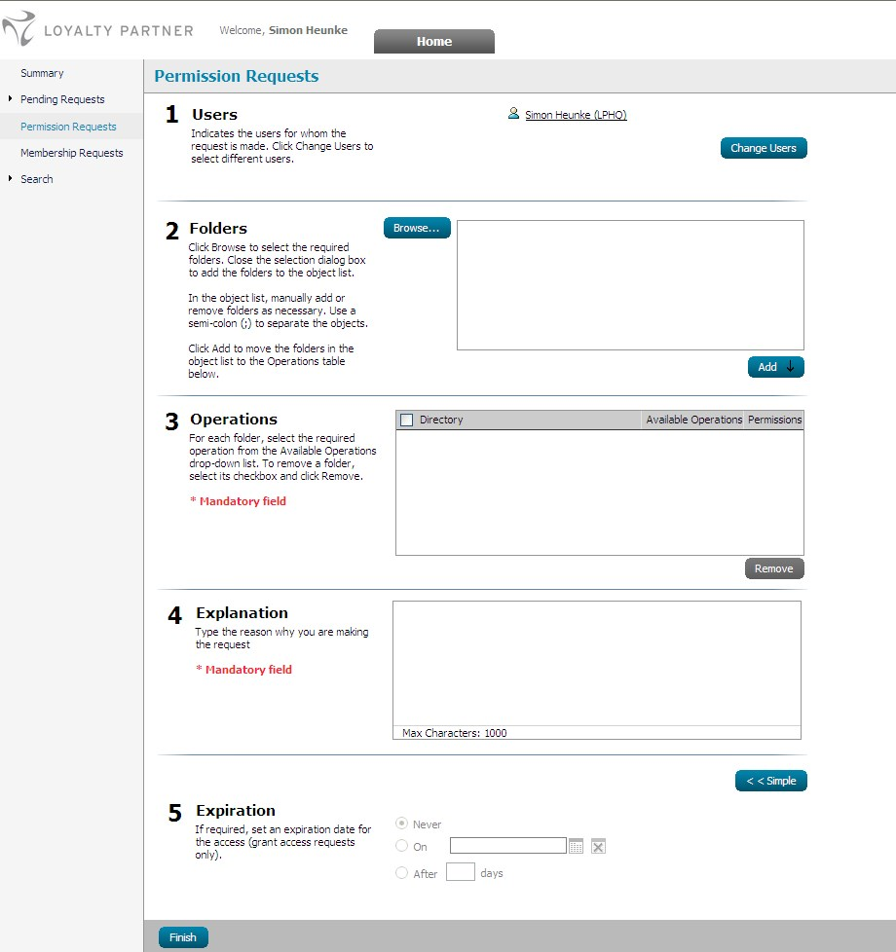

As you can see that window is split into five parts.

- Users

Here you can define for whom you would like to open a permission request. In most cases you will open them for yourself which is the standard definition. If you would like to open a request for a different user just click “Change User” and do the following:

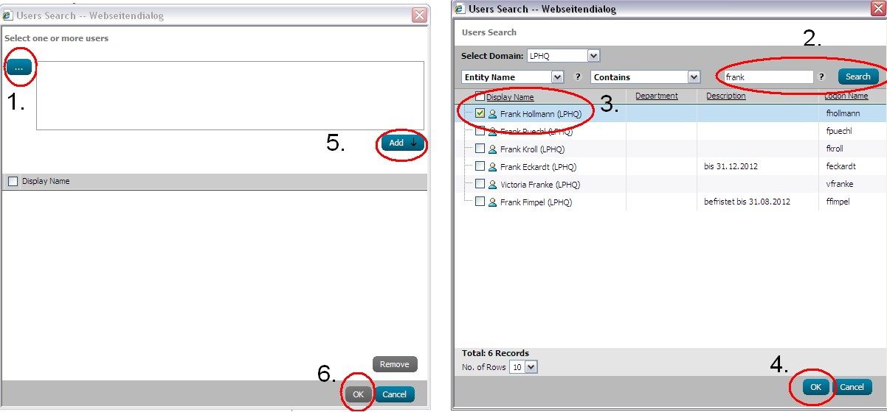

- Folders

At this point you have to choose the folder you would like to get access to. Just click onto “Browse…”, select the folder and click on “OK”. You can only request permission for the shown folders. Always select the folder, which is the nearest to the data you would like to access.

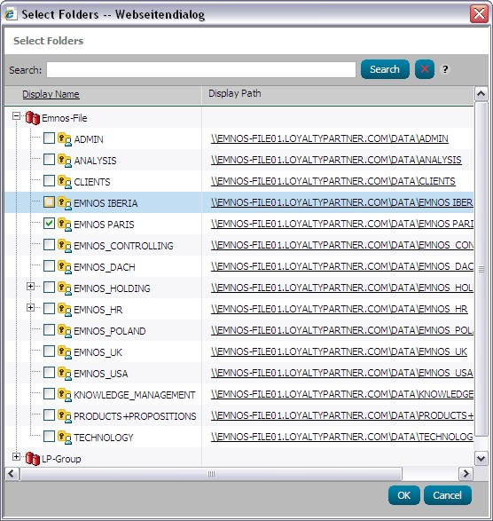

- Now you can see the selected folder. Just click “ADD” to go to the next step.

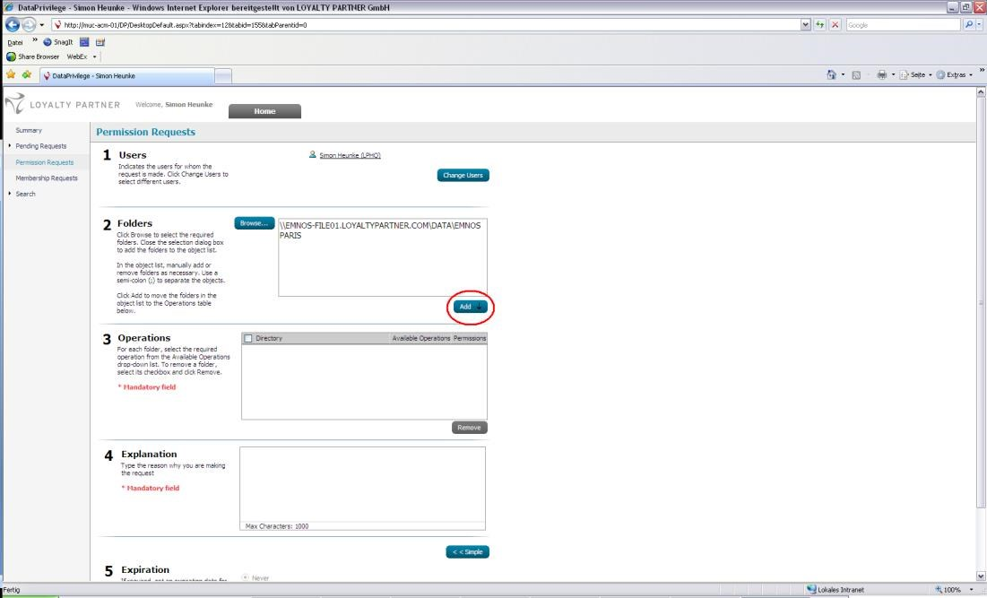

- Operations:

In that step you have to define the rights you would like to request. You can see the folder you added and two options you can change. The first one is “Available Operations”. Here you can select “Grant Access” or “Revoke Access” if you already got access. The second option is “Permissions”. Here you can either select “Read” or “Modify”. Read rights are explained by the name itself and modify just means read and write.

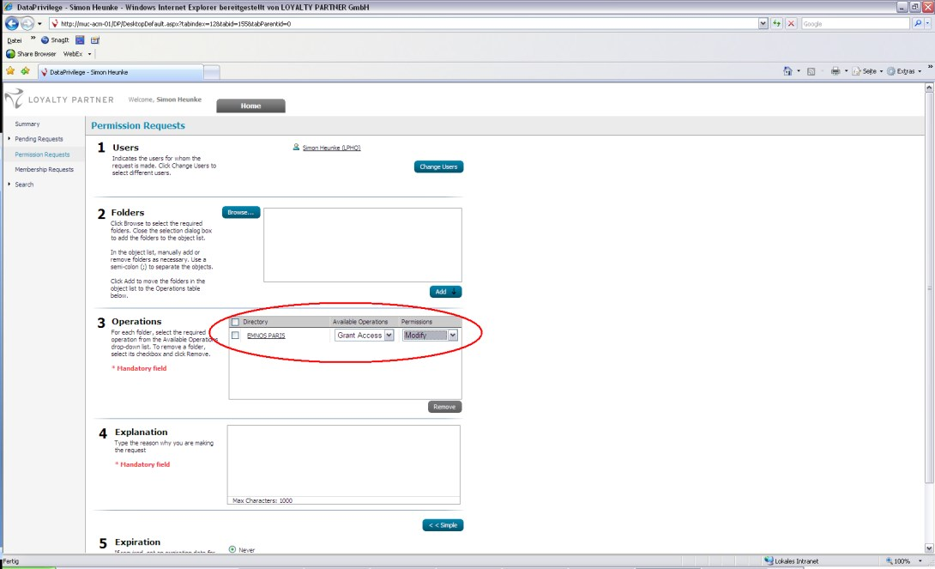
- Explanation

Here you have to give a short explanation why you need access to that folder, so that the Owner of that folder is able to handle your request easier. For example:

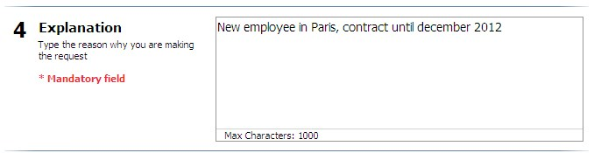

- Expiration

In this step you can define expiration for your permission.
You can choose the following three options:
  - Never
  - On specific date
  - After __ days

This option should be set if you know that you need the folder permission for a specific period. (Project, Substitution…)

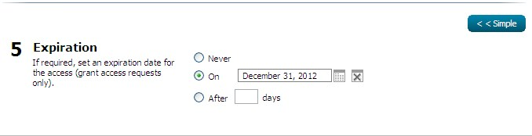

- Now you’re basically done. Just check your entered information again and click “Finish”.

- In the next window you can see a short summary of your request. If you would like to find out who will handle your request you can click onto “here”.

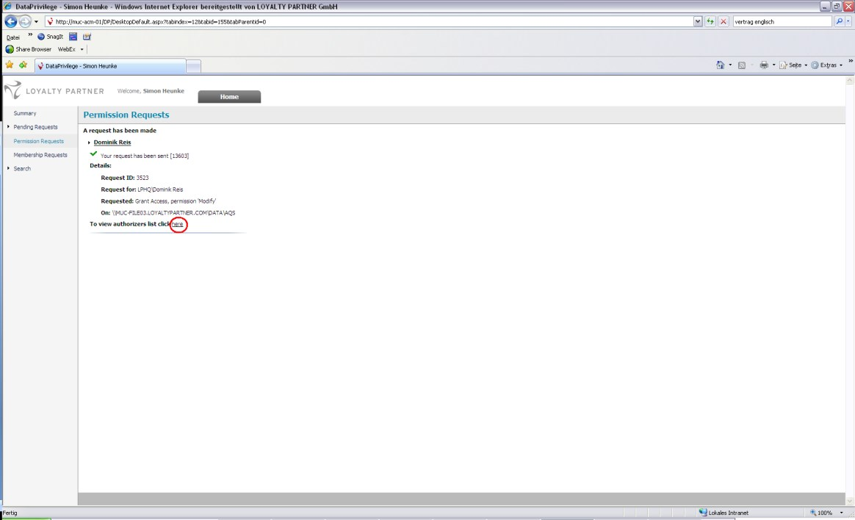

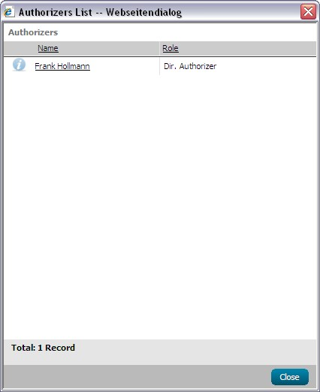

- Your permission request is now finished and the Owner of the folder can handle your request. You will automatically get an email when your request has been approved or declined it. The message will look like that:

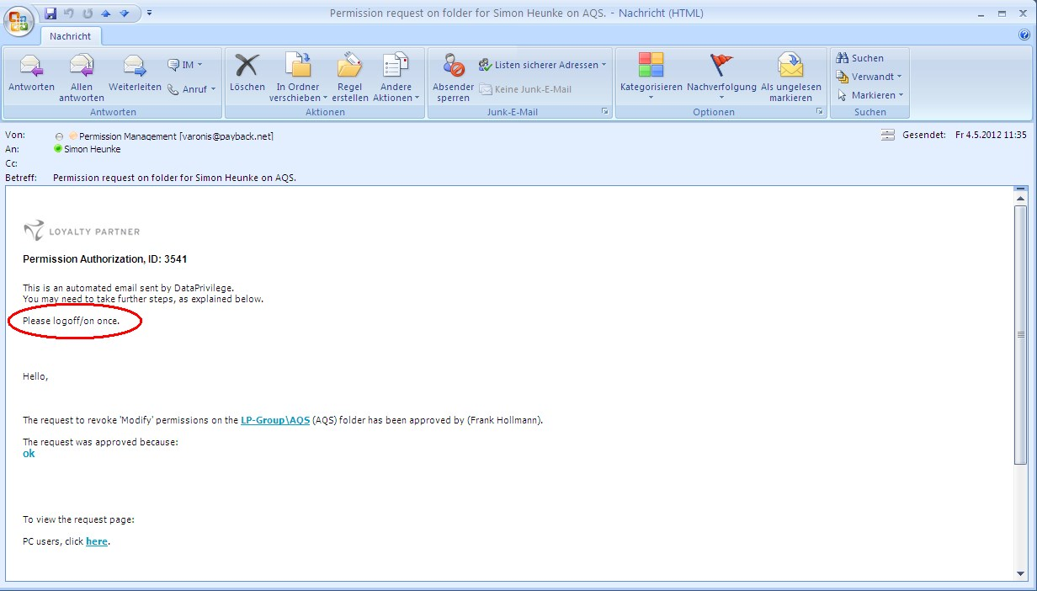

- If you would like to see your open requests you got two options:

  - Summary Screen

Just click onto “Summary” and you will see your latest requests. If you want to cancel your request just click the little “X” Symbol.
If you want to get some more information about your request just click onto the “i” symbol.

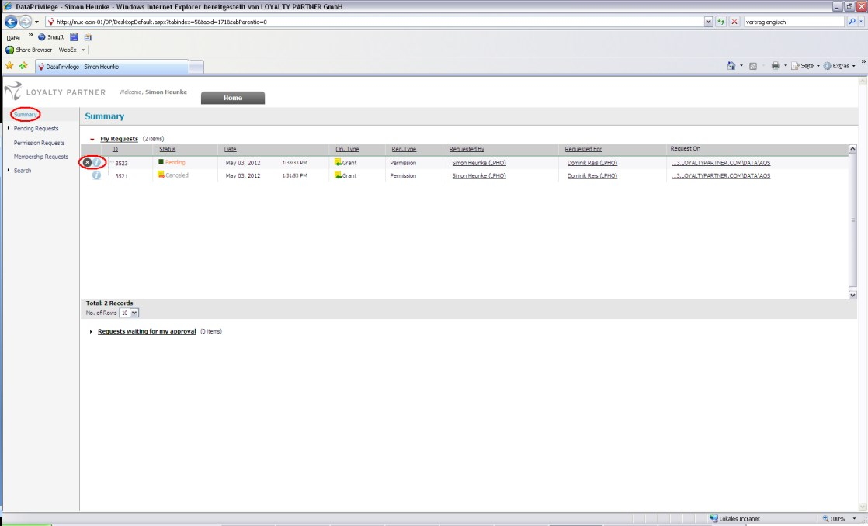

  - Pending Request

Click onto “Pending Requests” →”My Requests”
Now you can define some options if you would like to limit the results or just click onto “Search”. At the right side of the screen you can now see the results.

